GitHub Link: **https://github.com/speshori/Team-Project-Final-Web-Application_IS601**

**Graph Feature – Samir Peshori**

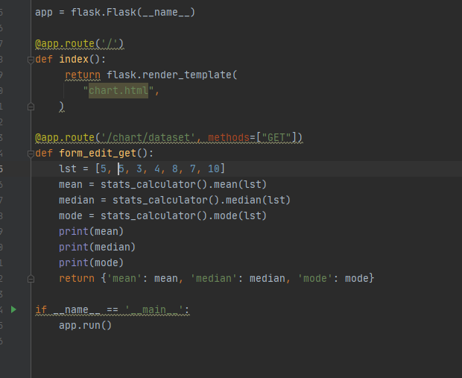

**First the list and values for mean, median, and mode are calculated from the stats calculator and by using the GET method are retrieved from the Flask server**

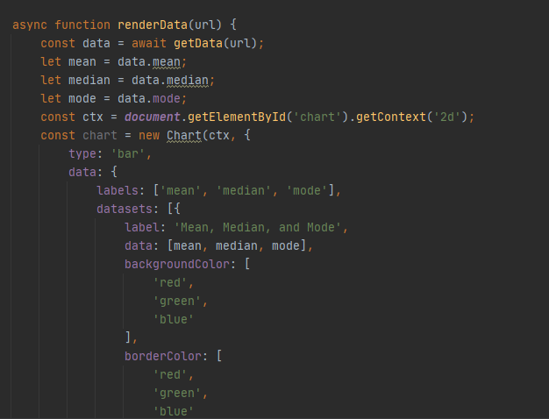

**Then the values are retrieved from the endpoint on the client side to display them with a JS graph to represent values for mean (6), median (4), and mode (5) below.**

